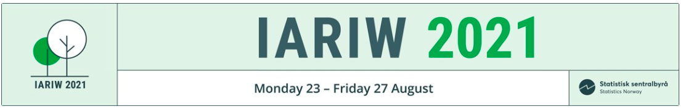

Title

Name
(Organisation)

Paper prepared for the 36th IARIW Virtual General Conference
August 23-27, 2021
IARIW Plenary Session: New Developments in Economic Measurement
Time: Monday, August 23, 2021 [14:00-18:30 CEST]

