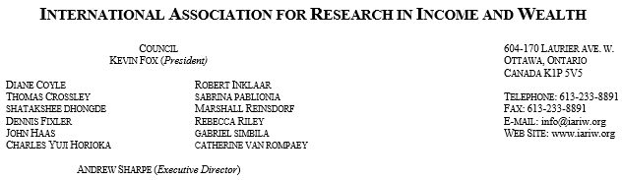

August 12, 2022
Dear IARIW member,
The scientific program for the 37th IARIW General Conference taking place at the Chamber of Commerce in Luxembourg August 22-26, 2022 is now finalized. The program can be found here.
All papers on the program are now publicly available through links on the conference program to conference participants, the IARIW membership, and the general public. The program represents the latest research on a wide range of topics in the income and wealth field. Indeed, the set of papers to be presented at the conference represents an important contribution to knowledge. IARIW members are strongly encouraged to read the papers,
Reminder of August 31 Deadline for Submission of Proposals for the IARIW-Bank of Italy Special Conference on Central Banks, Financial Markets and Inequality
IARIW members are reminded that August 31, 2022 is the deadline for submission of proposals for the IARIW-Bank of Italy conference entitled ”Central Banks, Financial Markets and Inequality” taking place in Naples, Italy March 29-April 1, 2023. The call for papers is posted here. The portal for submission of proposals for papers can be found here.
Sincerely,
Andrew Sharpe
Executive Director
International Association for Research in Income and Wealth
710-151 Slater Street
Ottawa, ON, Canada K1P 5H3
Tel: +1 (613) 233-8891
Fax: +1 (613) 233-8250
Email: andrew.sharpe@csls.ca
Website: www.iariw.org

