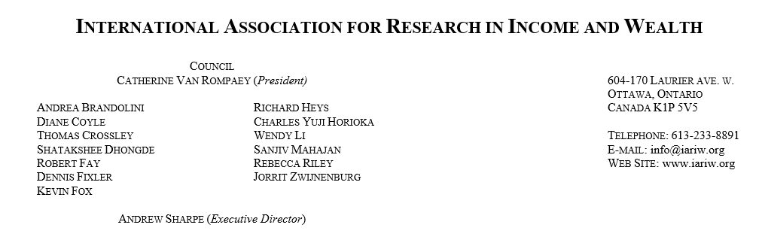
November 3, 2022
Dear IARIW Members,
The International Association for Research in Income and Wealth (IARIW) is pleased to announce a special conference, organized in partnership with the Centre for International Governance Innovation (CIGI), on the topic of the valuation of data. The event will be held November 2-3, 2023 in Waterloo, Ontario, Canada. The co-chairs of the program committee are Diane Coyle from Cambridge University and Bob Fay from CIGI. The call for papers is posted at https://iariw.org/wp-content/uploads/2022/11/Call-Papers-IARIW-CIGI.docx. Details on the conference are found at https://iariw.org/wp-content/uploads/2022/11/Outline-IARIW-CIGI.docx. The portal for submission of proposals for papers is located at https://forms.gle/EbitFGyNoho8W1s86. The deadline for submission is January 31, 2023.
In the digital world the economy appears increasingly driven by data. Indeed, one of the topics being addressed in the SNA update scheduled for release in 2025 is the question of the valuation of data and its place in the national accounts. IARIW members are strongly encouraged to submit proposals for this important conference. Please circulate the call for papers to any colleagues who might be interested in presenting a paper at the conference.
On November 11-13, 2022, the IARIW and the National Bureau of Statistics of Tanzania are holding the conference “Measuring Income, Wealth and Well-being in Africa” in Arusha, Tanzania. All the nearly 40 papers to be presented at the conference are now posted with the conference program on the IARIW website at https://iariw.org/iariw-tnbs-conference-program/ Members interested in income, wealth and well-being issues in Africa will find much new and innovative research in this set of papers.
The program for the IARIW-Bank of Italy conference “Central Banks, Financial Markets and Inequality” to be held in Naples, Italy March 29-April 1 will be released shortly.
Best Regards
Andrew Sharpe
Executive Director
IARIW

