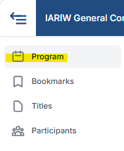
Accessing Presentations in Oxford Abstracts - Instructions for Discussants

Step 1 – Open the conference programme
Log in to the IARIW 2026 Oxford Abstracts platform https://virtual.oxfordabstracts.com/event/75057/program
and click Program in the left-hand menu.


Step 2 – Select the conference day
Choose the day on which your session takes place.

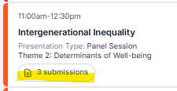
Step 3 – Open your session
Locate your session in the programme and click on the “3 submissions” button beneath the session title.

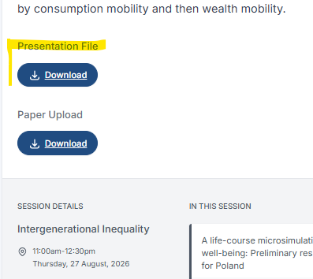
Step 4 – Select the assigned paper
From the list of submissions in your session, select the paper you have been assigned to discuss.
The paper's Submission page will open. Scroll down to the bottom of the page until you reach the Presentation File section.

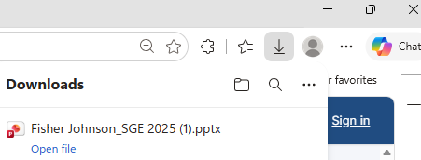
Step 5 – Download the presentation
Under Presentation File, click Download to access the presentation that was uploaded for that paper.
The file will be downloaded automatically and can normally be found in the Downloads folder of the room laptop.

Step 6 – Present in the room
Open the downloaded file from the Downloads folder and use it for projection in the conference room.

Important

External storage devices are not permitted
For security reasons, presentations must not be loaded from personal USB sticks, external hard drives or other external storage devices. Please use Oxford Abstracts as the primary source for presentation files.

Backup procedure
As a contingency measure, all presentation files will be downloaded from Oxford Abstracts and stored securely by the conference team on Sunday 23 August 2026.
These backup files correspond to the versions that were available in Oxford Abstracts on that date. Any updates uploaded after 23 August 2026 may therefore not be reflected in the backup copies.
Whenever Oxford Abstracts is available, it should be considered the authoritative source and the preferred way to access presentation files.

If you cannot find a presentation file
Please contact the room assistant or technical support team.

