If you created the original submission, below are the steps to access the portal to upload presentation files, the full paper, and discussant slides. If you did not submit the original submission and need to upload discussant files, please email them to the submitter of the paper so they can upload the files. If you do not know who the submitter of the paper is, please email us, info@appam.org. Please note that all discussants were sent their submitter’s contact information on July 24th.
Steps to Upload Presentation Files, a Paper, or Discussant Slides
- Go back to the Oxford Submission Form.
- Enter your email and password that you used to set up your Oxford account. If you can't remember your password, you'll have an opportunity to get a password reset.
- Once you are logged into Oxford, click on your submission and scroll down.
- You'll see three options (screenshot) for uploading files to Oxford, see below.
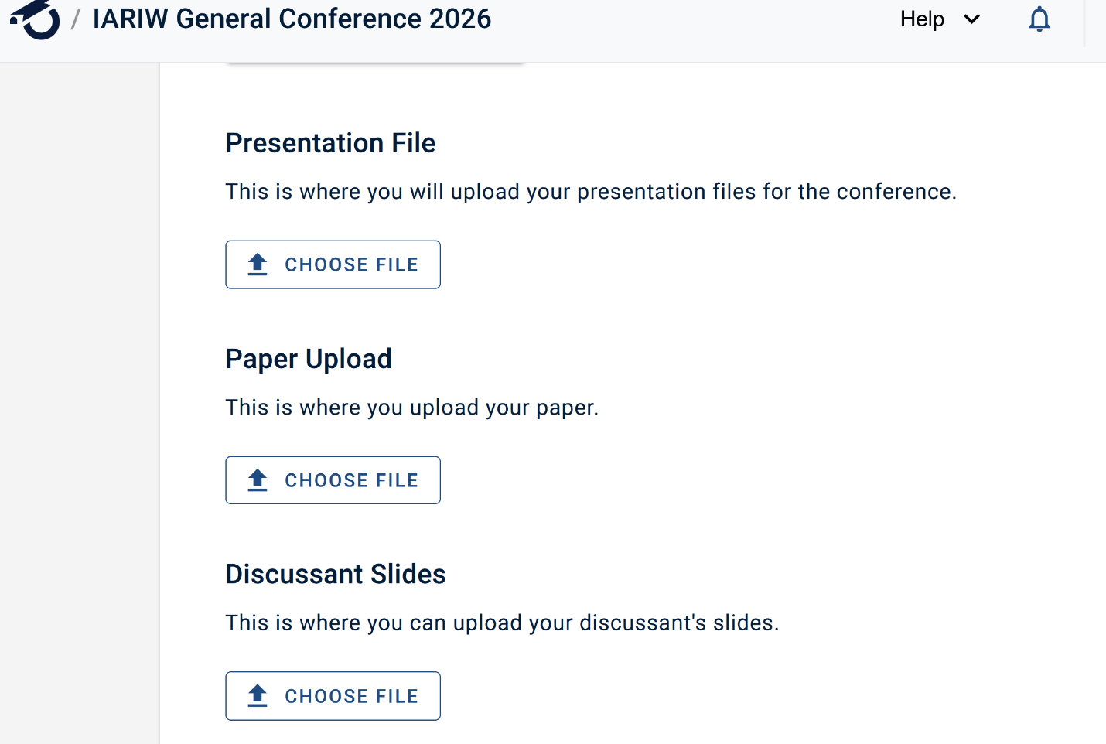
1) You can upload presentation slides for the presenter of the paper, if they have them. Presenter slides are not required.
2) You can upload your paper for the discussant to download and read. Please do that ASAP or email the paper directly to the discussant. If you do not have contact information for your discussant, please reach out to info@iariw.org.
3) You can upload discussant slides for the presentation of the paper. Discussant slides are due by August 19th.
Important Info:
- Please only upload PPT or PDF files.
- Please doublecheck your upload afterwards to make sure it renders correctly. You can do that by navigating to the public program here, finding your session, and, if a paper, presentation slides or discussant slides are uploaded, they will show up under the title of the paper, like below.
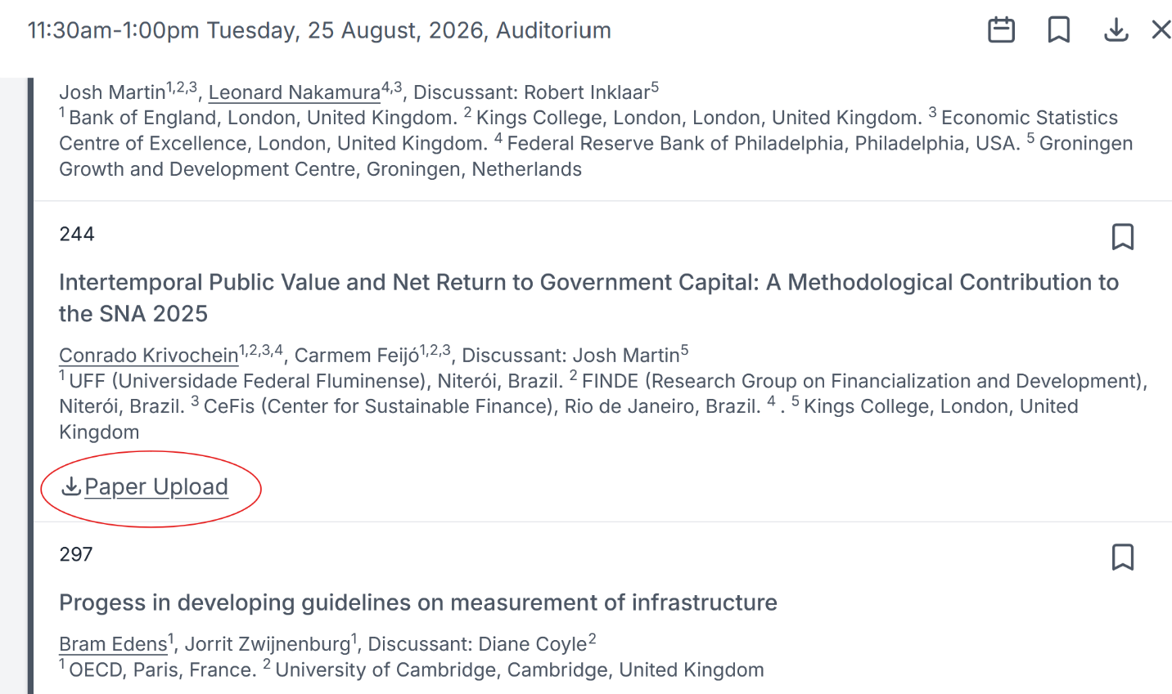
- If an upload includes audio, animation or anything else unusual, please let us know.
- Do not include any password protected files.
- Please include the name of your session, the day and time, and the discussant’s name in the file name.
- You will be accessing your slides during the presentation via the Online Program so best to familiarize yourself with how the Online Program works so you can access it easily on the day of the presentation.
Posters
If you are presenting a poster, we have arranged to have the posters printed in Brussels and delivered to the conference. This means you will not need to bring a printed poster to the conference. To accommodate printing, please upload a PDF of your poster (in A0 size, 84.1 x 118.9 cm, portrait orientation preferred), on the Oxford abstract portal by August 10th. Alternatively, you can send it to info@iariw.org.
You can visit here for some advice on creating a good poster, AEA/ASSA 2026 Poster video. And here. Or visit Better Posters: Plan, Design and Present an Academic Poster.

